**Learning Objectives**

* Define commonly used business accounts and classify each into one of five account types

The items that a business keeps track of are called **accounts**. Each of these accounts is one of five main types.

### Assets

[Insert Assets graphic]

Core Fit owns a number of valuable things including cash in its bank account and workout equipment, such as free weights. These are all assets. Core Fit sells some of its classes for cash and some on credit. The amount of cash Core Fit is owed by customers that have bought on credit is categorized as Accounts Receivable and is also an asset.

### Liabilities



The money Core Fit owes to others, such as the monthly rent for the studio, fall in the Accounts Payable account. In addition, if Core Fit took out a loan to help buy some new machinery or open a new location, the dues of that loan would be a liability that would fall in the Notes Payable account.

### Stockholders’ Equity



The value of the shares that Stella and Eddie own in Core Fit is known as Common Stock and is part of the stockholders’ equity account. Core Fit’s quarterly profits accumulate as Retained Earnings and are also part of the stockholders’ equity account.

### Revenue



All the fees that Core Fit earns from selling classes is revenue. This includes the fees generated from cash sales as well as credit sales.

### Expense

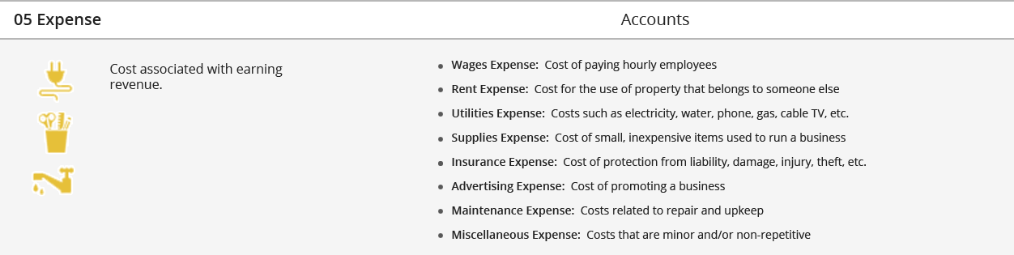

Core Fit incurs a number of costs to earn its revenue. These include (but are not limited to) salaries for its other trainers and receptionist, the rent of the studio, electricity costs and insurance. All these costs fall in the expense category.

### Test Your Understanding 2

Which account does a company use to keep track of amounts owed to it by its customers?

1. Accounts Payable
2. Accounts Receivable
3. Fees Earned
4. Common Stock

### Interactive Exercise 1: Account Classifications

**Instructions:** For each account type listed, select corresponding account that falls in that category.

|  |  |
| --- | --- |
| ACCOUNT TYPE | ACCOUNT |
| Asset | (a) Fees Earned   (b) Accounts Receivable   (c) Insurance Expense (d) Common Stock |
| Liability | (a) Retained Earnings    (b) Equipment (c) Accounts Payable   (d) Maintenance Expense |
| Stockholders’ Equity | (a) Land   (b) Supplies Expense   (c) Fees Earned (d) Retained Earnings |
| Revenue | (a) Cash  (b) Fees Earned   (c) Common Stock (d) Rent Expense |
| Expense | (a) Wages Expense  (b) Note Payable (c) Fees Earned    (d) Building |

*[Hint:* Assets are items of value to a business. Liabilities are debts. Stockholders’ equity is the worth of the corporate owners of a business. Revenue represents income, and expenses are costs of generating revenue.*]*